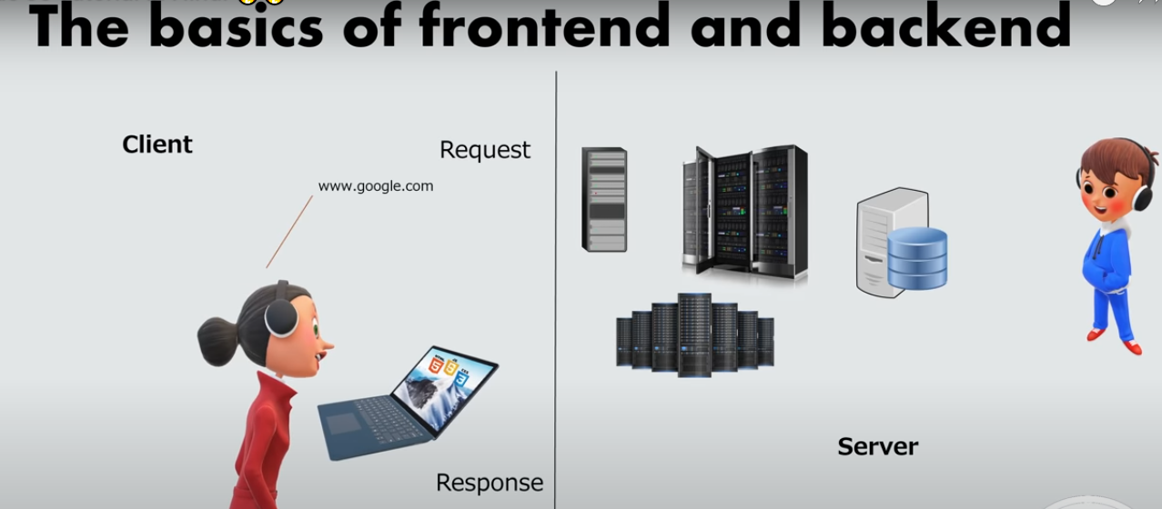

Node Js

## What is Node.js?

* Node.js is an open source server environment
* Node.js is free
* Node.js runs on various platforms (Windows, Linux, Unix, Mac OS X, etc.)
* Node.js uses JavaScript on the server
* It is a popular tool for almost any kind of project!
* Node.js runs the V8 JavaScript engine, the core of Google Chrome, outside of the browser.
* A Node.js app is run in a single process, without creating a new thread for every request.
* Node.js provides a set of asynchronous I/O primitives in its standard library that prevent JavaScript code from blocking and generally, libraries in Node.js are written using non-blocking paradigms, making blocking behavior the exception rather than the norm When Node.js needs to perform an I/O operation, like reading from the network, accessing a database or the filesystem, instead of blocking the thread and wasting CPU cycles waiting, Node.js will resume the operations when the response comes back.

Node.js uses asynchronous programming!

A common task for a web server can be to open a file on the server and return the content to the client.

Here is how PHP or ASP handles a file request:

1. Sends the task to the computer's file system.
2. Waits while the file system opens and reads the file.
3. Returns the content to the client.
4. Ready to handle the next request.

Here is how Node.js handles a file request:

1. Sends the task to the computer's file system.
2. Ready to handle the next request.
3. When the file system has opened and read the file, the server returns the content to the client.

Node.js eliminates the waiting, and simply continues with the next request.

Node.js runs single-threaded, non-blocking, asynchronous programming, which is very memory efficient.

## What Can Node.js Do?

* Node.js can generate dynamic page content
* Node.js can create, open, read, write, delete, and close files on the server
* Node.js can collect form data
* Node.js can add, delete, modify data in your database

## What is a Node.js File?

* Node.js files contain tasks that will be executed on certain events
* A typical event is someone trying to access a port on the server
* Node.js files must be initiated on the server before having any effect
* Node.js files have extension ".js"

## Download Node.js

The official Node.js website has installation instructions for Node.js: [https://nodejs.org](https://nodejs.org/)

Run : start => node.js

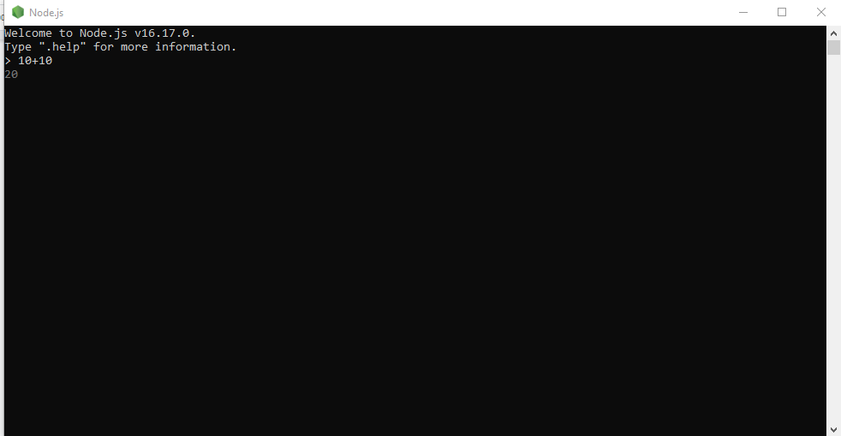

Opermn one cmd node

Create a Node.js file named "myfirst.js", and add the following code:

Myfirst.js

Code : console.log(‘Hello World’);

Run : node Myfirst

Output : Hello World’

var http = require('http');

http.createServer(function (req, res) {

res.writeHead(200, {'Content-Type': 'text/html'});

res.end('Hello World!');

}).listen(8080);

Run in cmd : C:\Users*Your Name*>node myfirst.js

Run : localhost/8080

# Node.js Modules

## What is a Module in Node.js?

Consider modules to be the same as JavaScript libraries.

A set of functions you want to include in your application.

## Built-in Modules

Node.js has a set of built-in modules which you can use without any further installation.

Node.js has a set of built-in modules which you can use without any further installation.

Here is a list of the built-in modules of Node.js version 6.10.3:

| **Module** | **Description** |
| --- | --- |
| [assert](https://www.w3schools.com/nodejs/ref_assert.asp) | Provides a set of assertion tests |
| [buffer](https://www.w3schools.com/nodejs/ref_buffer.asp) | To handle binary data |
| child_process | To run a child process |
| [cluster](https://www.w3schools.com/nodejs/ref_cluster.asp) | To split a single Node process into multiple processes |
| [crypto](https://www.w3schools.com/nodejs/ref_crypto.asp) | To handle OpenSSL cryptographic functions |
| [dgram](https://www.w3schools.com/nodejs/ref_dgram.asp) | Provides implementation of UDP datagram sockets |
| [dns](https://www.w3schools.com/nodejs/ref_dns.asp) | To do DNS lookups and name resolution functions |
| domain | Deprecated. To handle unhandled errors |
| [events](https://www.w3schools.com/nodejs/ref_events.asp) | To handle events |
| [fs](https://www.w3schools.com/nodejs/ref_fs.asp) | To handle the file system |
| [http](https://www.w3schools.com/nodejs/ref_http.asp) | To make Node.js act as an HTTP server |
| [https](https://www.w3schools.com/nodejs/ref_https.asp) | To make Node.js act as an HTTPS server. |
| [net](https://www.w3schools.com/nodejs/ref_net.asp) | To create servers and clients |
| [os](https://www.w3schools.com/nodejs/ref_os.asp) | Provides information about the operation system |
| [path](https://www.w3schools.com/nodejs/ref_path.asp) | To handle file paths |
| punycode | Deprecated. A character encoding scheme |
| [querystring](https://www.w3schools.com/nodejs/ref_querystring.asp) | To handle URL query strings |
| [readline](https://www.w3schools.com/nodejs/ref_readline.asp) | To handle readable streams one line at the time |
| [stream](https://www.w3schools.com/nodejs/ref_stream.asp) | To handle streaming data |
| [string_decoder](https://www.w3schools.com/nodejs/ref_string_decoder.asp) | To decode buffer objects into strings |
| [timers](https://www.w3schools.com/nodejs/ref_timers.asp) | To execute a function after a given number of milliseconds |
| [tls](https://www.w3schools.com/nodejs/ref_tls.asp) | To implement TLS and SSL protocols |
| tty | Provides classes used by a text terminal |
| [url](https://www.w3schools.com/nodejs/ref_url.asp) | To parse URL strings |
| [util](https://www.w3schools.com/nodejs/ref_util.asp) | To access utility functions |
| v8 | To access information about V8 (the JavaScript engine) |
| [vm](https://www.w3schools.com/nodejs/ref_vm.asp) | To compile JavaScript code in a virtual machine |
| [zlib](https://www.w3schools.com/nodejs/ref_zlib.asp) | To compress or decompress files |

## Include Modules

To include a module, use the require() function with the name of the module:

var http = require('http');

Now your application has access to the HTTP module, and is able to create a server:

http.createServer(function (req, res) {

res.writeHead(200, {'Content-Type': 'text/html'});

res.end('Hello World!');

}).listen(8080);

## Create Your Own Modules

You can create your own modules, and easily include them in your applications.

The following example creates a module that returns a date and time object:

### Example

Create a module that returns the current date and time:

exports.myDateTime = function () {

return Date();

};

THEN YOU CAN ACCESS ANYWHERE IN MODULE

Notice that we use ./ to locate the module, that means that the module is located in the same folder as the Node.js file.

var http = require('http');

var dt = require('./myfirstmodule');

http.createServer(function (req, res) {

res.writeHead(200, {'Content-Type': 'text/html'});

res.write("The date and time are currently: " + dt.myDateTime());

res.end();

}).listen(8080);

## Node.js as a Web Server

The HTTP module can create an HTTP server that listens to server ports and gives a response back to the client.

Use the createServer() method to create an HTTP server:

The function passed into the http.createServer() method, will be executed when someone tries to access the computer on port 8080.

var http = require('http');

//create a server object:

http.createServer(function (req, res) {

res.write('Hello World!'); //write a response to the client

res.end(); //end the response

}).listen(8080); //the server object listens on port 8080

## Add an HTTP Header

If the response from the HTTP server is supposed to be displayed as HTML, you should include an HTTP header with the correct content type:

var http = require('http');

http.createServer(function (req, res) {

res.writeHead(200, {'Content-Type': 'text/html'});

res.write('Hello World!');

res.end();

}).listen(8080);

The first argument of the res.writeHead() method is the status code, 200 means that all is OK, the second argument is an object containing the response headers.

## Read the Query String

The function passed into the http.createServer() has a req argument that represents the request from the client, as an object (http.IncomingMessage object).

This object has a property called "url" which holds the part of the url that comes after the domain name:

var http = require('http');

http.createServer(function (req, res) {

res.writeHead(200, {'Content-Type': 'text/html'});

res.write(req.url);

res.end();

}).listen(8080);

If you have followed the same steps on your computer, you should see two different results when opening these two addresses:

<http://localhost:8080/summer>

Will produce this result:

/winter